Appendix 1

THE II INTERNATIONAL ETHNO-JAZZ MUSIC ENSEMBLE
COMPETITION “Guoyu pa Jazz”

ENSEMBLE EVALUATION CRITERIA

Each evaluation criterion is rated from 1 (lowest) to 10 (highest) points.

- Repertoire relevance (1-10 points);
- Use of traditional music elements (1-10 points);
- Quality of arrangements, instrumentation (1-10 points);
- Originality (1-10 points);
- Quality of improvisation (1-10 points);
- Ensemble interaction (1-10 points);
- Sense of time (groove/feel) and rhythm accuracy (1-10 points);
- Technical mastery (1-10 points);
- Intonation (1-10 points);
- Visual image (1-5 points);
- Stage culture (1-5 points);
- Contact with the audience (1-5 points).

Appendix 2

THE II INTERNATIONAL ETHNO-JAZZ MUSIC ENSEMBLE
COMPETITION “Guoyu pa Jazz”

10-POINT SCALE AND EXPLANATION

Points | Explanation
10 | Excellent - the criterion is fulfilled perfectly, accurately and convincingly, at a high professional level.
9 | Almost excellent - the criterion is fulfilled at a high level.
8 | Very good - the criterion is fulfilled at a very good level, however, the quality of some components is insufficient.
7 | Good - the criterion is fulfilled well, there are shortcomings in the quality of some components.
6 | The criterion is fulfilled almost well - the quality of some components is unconvincing.
5 | The criterion is fulfilled mediocrely, there are shortcomings or partial compliance with the competition regulations.
4 | The criterion is fulfilled partially - the level of some components is unstable, ill-considered and unclear.
3 | The criterion is fulfilled poorly, almost does not meet the requirements of the regulations.
2 | The criterion is fulfilled very poorly, does not meet the requirements of the regulations.
1 | The criterion is fulfilled very, very poorly, does not meet the requirements of the regulations.

5-POINT SCALE AND EXPLANATION

Points | Explanation
5 | The criterion is fulfilled perfectly, accurately and convincingly, at a high professional level, free, lively and vivid performance, artistry.
4 | The criterion is fulfilled at a very good level, well thought out and developed, however, the quality of some components is insufficient.
3 | The criterion is fulfilled mediocrely, shortcomings are noticeable, the performance is monotonous.
2 | The criterion is fulfilled satisfactorily, but unconvincingly.
1 | The criterion is fulfilled very, very poorly.

Appendix 3

THE III INTERNATIONAL ETHNO-JAZZ MUSIC ENSEMBLE
COMPETITION “Guoyu pa Jazz”

SUGGESTIONS FOR THE ARRANGEMENT OF A FOLK SONG
(Preferably to include several of the elements)

- Perform a folk song with the dialect and singing manner/tone intended for the local tradition:
- Include folk music instruments (e.g. Latvian folk music instruments https://www.tautasmuzikasinstrumenti.lv/, African kalimba/sanza, Spanish castanets, US banjo, etc.)
- Use of ancient melodies;
- Representation of the playing style of a traditional musical instrument (e.g. violin playing style in Latvian or Norwegian folk music, variation and improvisation within the framework of the relevant tradition);
- Inclusion of elements of world music (e.g., African rhythms, gamelan orchestra, Georgian polyphony, overtone singing traditions, klezmer instrumental music, etc.).

Appendix 4

STAGE PLAN

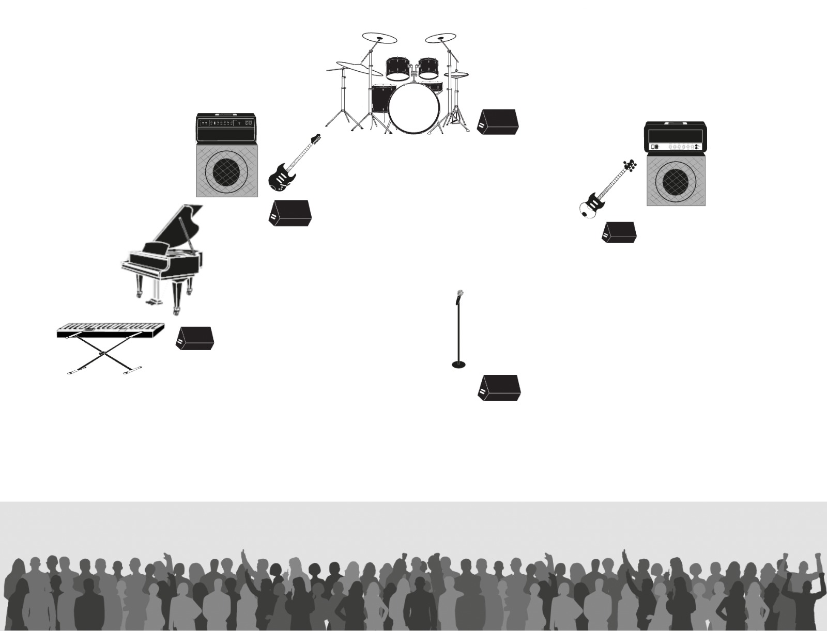

Appendix 5
INPUT LIST
Guoyu pa Jazz (name of the ensemble)
Input list
Input | Instrument | Source | Note
1 | Kick drum | MIC | Mic stand
2 | Snare | MIC | Mic stand
3 | Hi hat | MIC | Mic stand
4 | Tom1 | MIC | Clip
5 | Tom2 | MIC | Clip
6 | Floor tom | MIC | Clip
7 | OH L | MIC | Mic stand
8 | OH R | MIC | Mic stand
9 | Bass | Dibox | Jack
10 | GTR | MIC | Gtr c.Fender, Jack
11 | Piano L | Dibox
12 | Piano R | Dibox
13 | Key L | Dibox
14 | Key R | Dibox
15 | Vocal | MIC | Mic stand
16
17
18
19
20
21
22
23
24
25
26
27
28
29
30
AUX
1 | Monitor wedge |  | Vocal 2x
2 | Monitor wedge |  | Drum
3 | Monitor wedge |  | Guitar
4 | Monitor wedge |  | Bass
5 | Monitor wedge |  | Piano
6
7

(Educational institution form)

certification

place

January 4, 2026 Nr.1/1-1

Educational institution name certifies that the following educatees:
1) name, surname/study year,
2) name, surname/study year,
3) name, surname/study year,
4) name, surname/study year

are Educational institution name students and will participate in the
III International Ethno-jazz music ensemble competition “Guoyu pa JAZZ” organized by
Competence Centre of Arts Education „Latgale Secondary School of Music and Art” on February 12, 2026 at the Embassy of Latgale GORS in Rezekne, Latvia. The submitted program complies with the competition regulations (2 pieces in original arrangement).

Principal (signature) Name, surname

Appendix 7
INDIVIDUAL EVALUATION SHEET FOR JURY COMMISSION MEMBER

Ensemble name:

Evaluation criterion | Points earned (mark with X) |  |  |  |  |  |  |  |  |  | Notes, comments
Evaluation criterion | 1 | 2 | 3 | 4 | 5 | 6 | 7 | 8 | 9 | 10 | Notes, comments
1. Repertoire relevance

2. Use of traditional music elements

3. Quality of arrangements, instrumentation

4. Originality

5. Quality of improvisation

6. Ensemble interaction

7. Sense of time (groove/feel) and rhythm accuracy

8. Technical mastery

9. Intonation

10. Visual image

11. Stage culture

12. Contact with the audience

 | Total:

Jury member:

